**Hadoop 2.X components:-**

Hadoop 2.X has two components i.e.

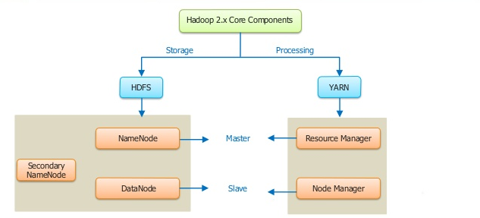

**Name Node:- (Master )**

* Its just like a ram it stores all the metadata and it will be maintained under the high performance system.
* Master of the system maintains and manages the blocks present on data nodes.

**Data Node : -(Slave)**

* Data nodes are the slaves which are deployed on each commodity system.
* It provides actual data storage.
* Responsible for read and write request from the client.

Job tracker:-

* Job tracker have task tracker .
* In the task tracker have the MapReduce.
* Above MapReduce is a programming model used for retrieving and analyzing data. This functionality present in the slave.